# Furniture Store Client Requirements

This document describes the specifications, by which the front-end client is created. You may use it as a reference during the implementation of a REST API that serves data in the expected format.

## Implement Furniture Store

You can make requests to the following endpoints:

* Register User (POST): **http://localhost:3030/users/register**
* Login User (POST): **http://localhost:3030/users/login**
* Logout User (GET): [**http://localhost:3030/users/logout**](http://localhost:3030/user/logout)
* Create Furniture (POST): **http://localhost:3030/data/catalog**
* All Furniture (GET): **http://localhost:3030/data/catalog**
* Furniture Details (GET): [**http://localhost:3030/data/catalog/:id**](http://localhost:3030/data/furniture/:id)
* Update Furniture (PUT):[**http://localhost:3030/data/catalog/:id**](http://localhost:3030/data/furniture/:id)
* Delete Furniture (DELETE): **http://localhost:3030/data/catalog/:id**
* My Furniture (GET): [**http://localhost:3030/data/catalog?where=_ownerId%3D%22{userId}%22**](http://localhost:3030/data/catalog?where=_ownerId%3D%22%7buserId%7d%22)

### Guest (not logged in)

**Guest** navigation example:



### Users (logged in)

**User** navigation example:



### All Furniture

List **all** **furniture** inside the **store**. Display appropriate links in the navigation bar, based on the user session.

Clicking on any of the **Details** buttons should **redirect to details**.

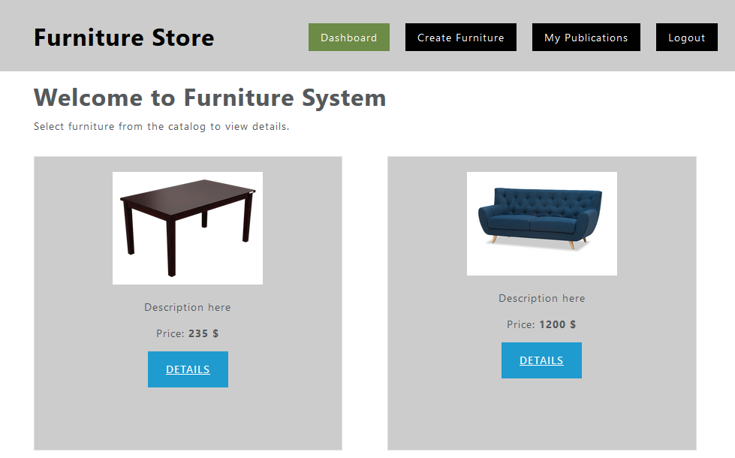

### Register User

You need to write the functionality for the registration of a new user. By clicking the "**Register**" button you have to load the registration form. Register a user inside the database with **email**, **password.** **Password** inside the database must be **hashed** (use bcrypt) and both **passwords** must **match**!

When the "**Register**" button of the form is clicked you need to send a post request.

If the registration is **successful** you can **redirect to dashboard page**.

### Login User

If the **user has already registered**, the user can login by using **the login form**. After **successful** login the user should be **redirected to dashboard page**. Save the returned token in the session storage, and send it with every request.

### Logout User

The **logged-in user** can be **logged out** by clicking the **logout button**. Write the functionality for this action.

### Create Furniture

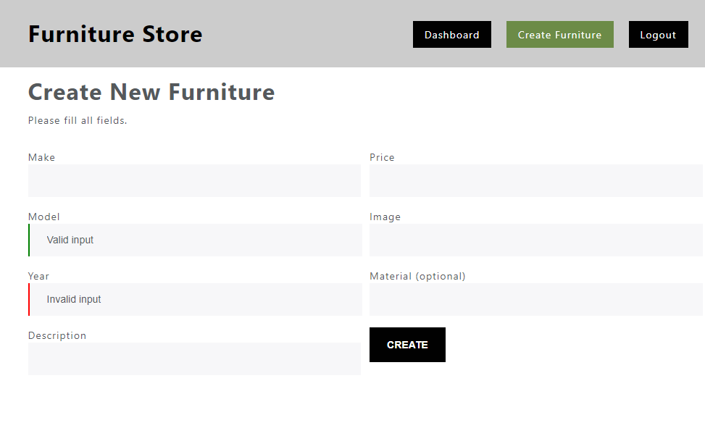

Validate fields:

* Make and Model must be **at least 4 symbols long**
* Year must be **between 1950 and 2050**
* Description must be **more than 10 symbols**
* Price must be a **positive number**
* Image **URL is required**
* Material is **optional**

By valid input you can **add the "is-valid" class** to the input field, and **by invalid** the **"is-invalid" class.**

If the creation is **successful** show **redirect to dashboard page**.

### Furniture Details

Get the **id** from the **URL** and **display** the information. If **the logged user is the creator** the buttons "**Edit**" and "**Delete**" should be **visible** (can be used), otherwise they should not be visible.

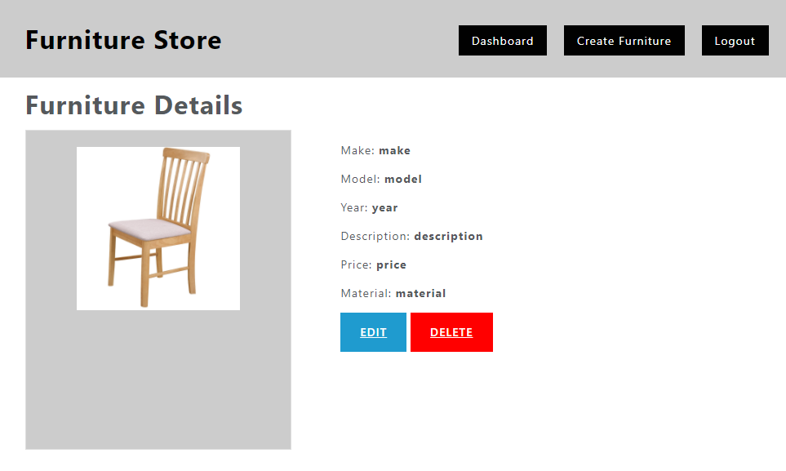

### Update Furniture

If the **logged in user** is **the creator** then can **edit** the furniture details. When the form is **loaded** **all the fields** must be **filled up** with the **information from the server**. **Validation** should be the same as the validation by creating new furniture. **PUT request** must be sent.

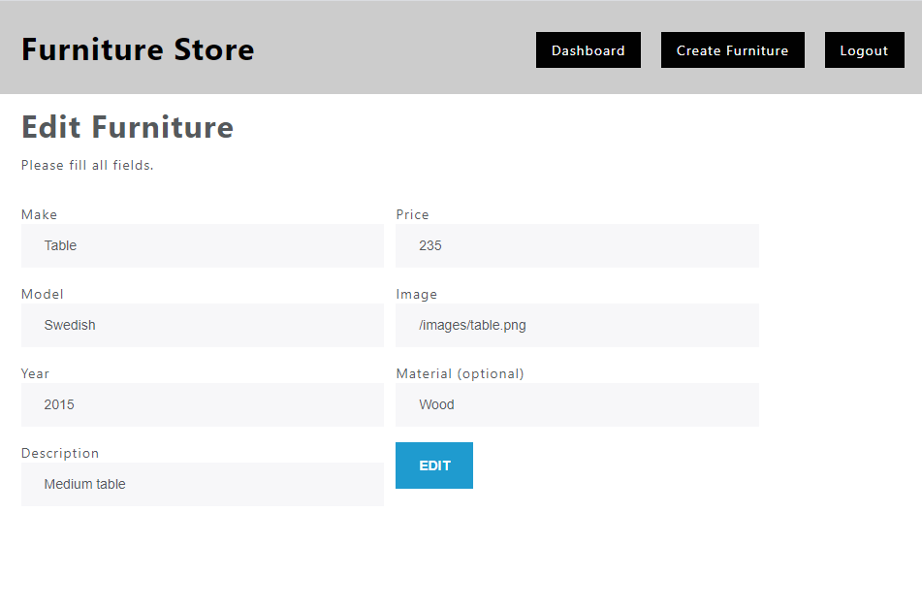

### Delete Furniture

By clicking on "**Delete**" button the app needs **first confirmation for deleting** (you can use alert or another custom-made notification)then sends **DELETE request** and **deletes the furniture**. Then the app **redirects** to the **dashboard**.

### My Furniture

A logged-in user can see a list of their own publications by clicking the link **“My Publications”** in the navigation bar. Display a page similar to the main catalog (dashboard), but only show the records that are associated with the currently logged-in user.

